**Project Report**

**Visualizations**

**Bar-Plot- Cluster and Purchase freq**

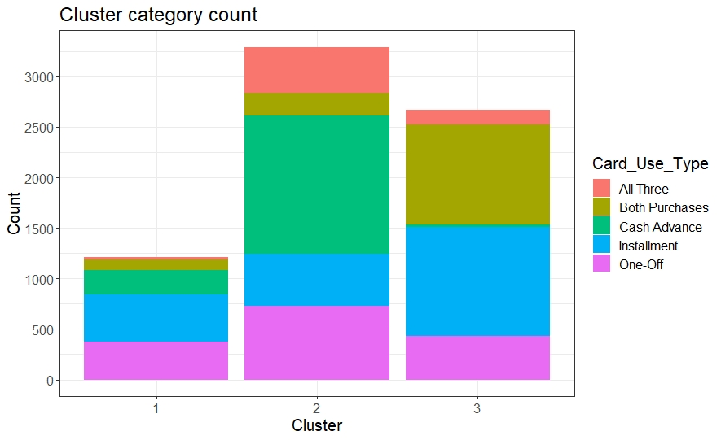

**Cluster 1-1217, Cluster2-3292, Cluster3-2670**

**Scatter-Plot-Monthly avg purchase and purchase freq**

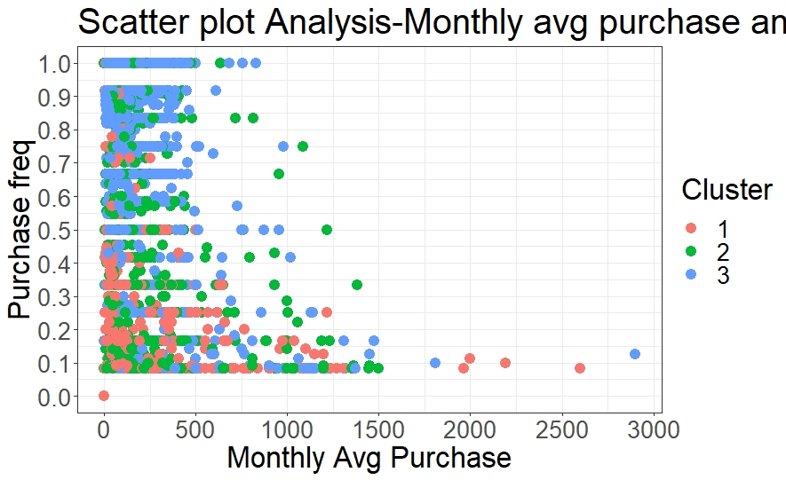

Cluster 1- has low purchase frequency

Cluster 2- has equal spread of purchase frequency as well as monthly average

Cluster 3- has almost higher purchase frequency >0.4, also has a little lower monthly average purchase

**Scatter-Plot-Monthly avg cash adv and cash adv freq**

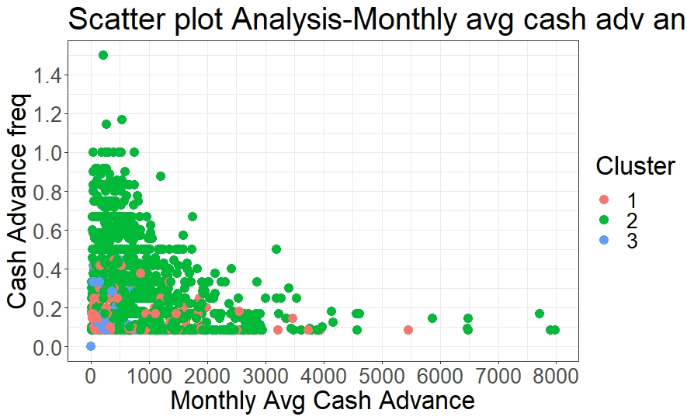

Cluster 1 and Cluster 3 has low Cash_advance_frequency.

Cluster 1 has 0-decent monthly cash adv average

Cluster 2 has good purchase frequency as well as good monthly average cash adv.

**Bar-Plot- Cluster and cash adv freq**

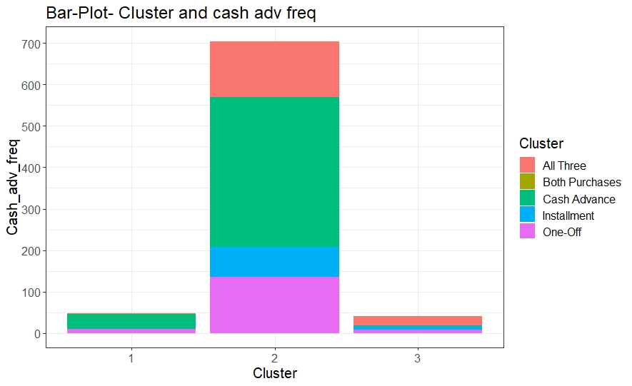

Most of the good Cash adv users belong to Cluster2.

Cluster 1 users use Cash adv amt but at very low frequency

Cluster 3 don't much use cash adv amt.

**Scatter-Plot- Payment Ratio and Credit Limit**

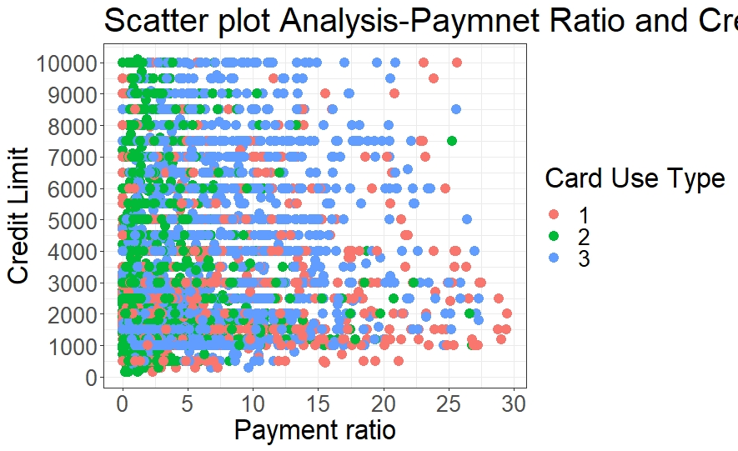

Cluster2 has low payment ratio but the credit limit is equally spread which makes half of them consider as potential buyers (Credit Limit more than mean)

Cluster 1 has low credit limit but payment ratio is equally distributed.

Cluster 3 has equal spread of credit limit as well as payment ratio.

**Scatter-Plot-Balance and credit limit**

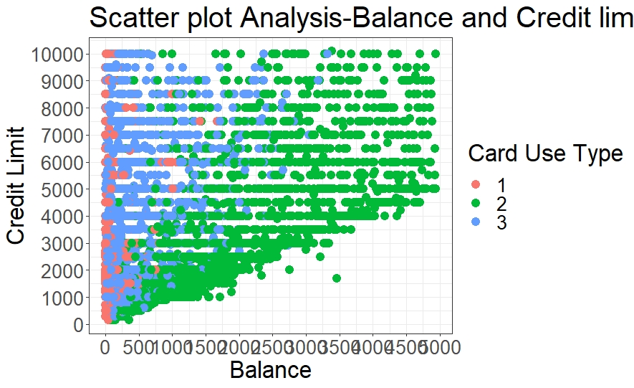

Cluster 2 trend:- Cluster 2 has balance and credit limit directly propotional i.e low credit limit-low balance, high credit limit- high balance

which makes cluster 2 as evidently highly potentional customers. The reason for low payment ratio with low credit limit in previous graph is due to minimal credit limit and balance.

Cluster 1 has low balance and are highly concentrated among low credit limit. which tells us that they are good customers but weren't provided with much facility to imrove their credit limit.

Cluster 3 has always low balance. Low balance-Low credit limit. Low balance-High credit limit

**Scatter-Plot-Prc Full paymnet and Limit usage**

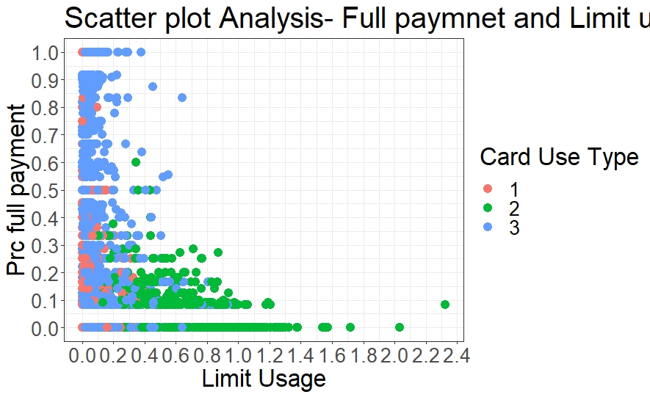

Cluster 1 has very low limit usage but pr full payment is somewhat distributed.

Cluster 2 has quite high limit usage compared to two but very low prc full paymnet

Cluster 3 has low limit usage but prc full payment is distributed.

**Scatter-Plot-Balance and Balance frequency**

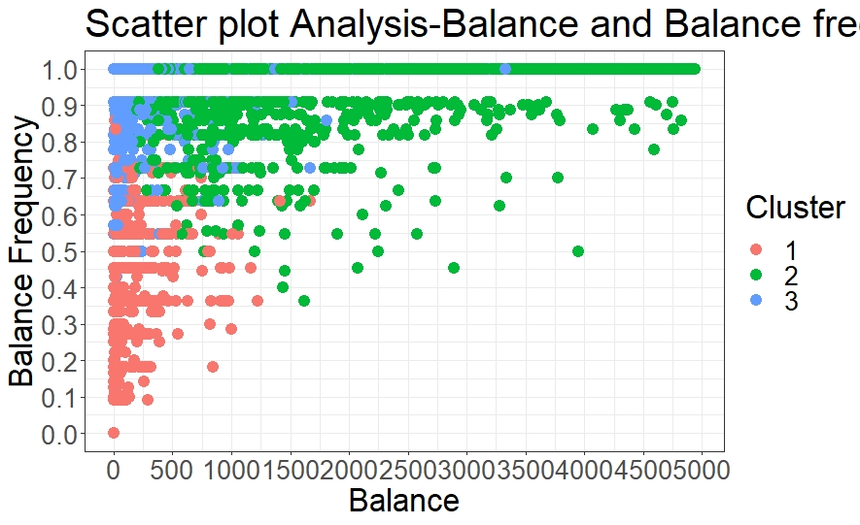

Cluster 1 has low balance frequeny and low bakance

Cluster 2 has high balance and high balance frequncy

Cluster 3 has low balance high balance frequency

**Scatter-Plot-One off purchase and one-off purchase freq**

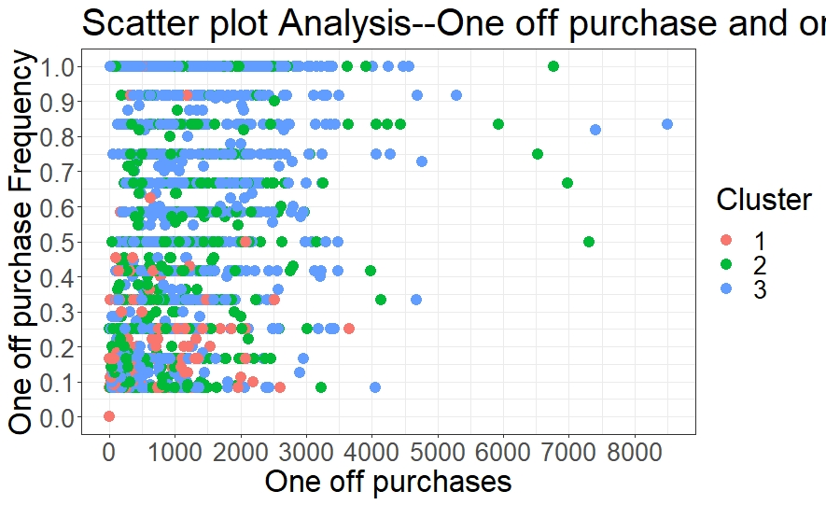

Cluster 1- has low one off purchases and low freq

Cluster 2- has low one off ourchases and freq evenly distributed

Cluster 3- has high one off purchases and hig freq

**Scatter-Plot-Installment purchase and Inst purchase freq**

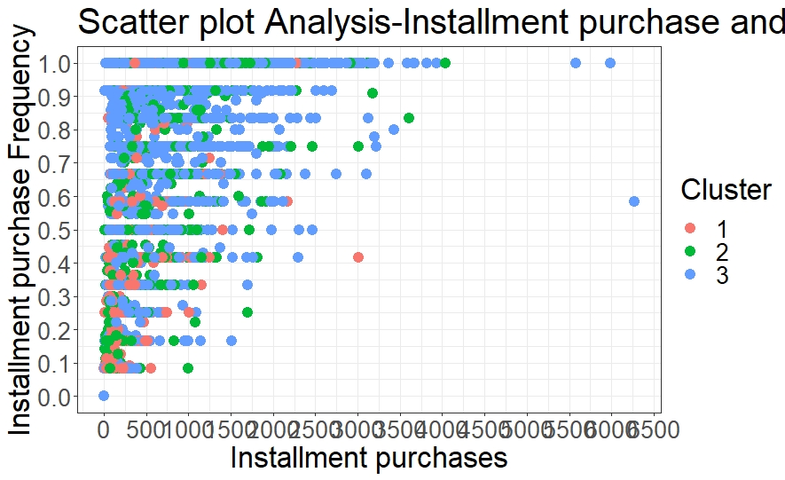

Cluster 1- has low Inst purchases and low freq

Cluster 2- has low Inst purchases and freq evenly distributed

Cluster 3- has high Inst purchases and hig freq

**Characteristics Analysis**

**Characteristics of Cluster 1(Good Payers, Hesitant user): -**

1. Not a frequent credit card user type.
2. Most of the customers under cluster 1 use cash advance transaction and that too in lower frequency.
3. Users have very low credit limit and high payment ratio(Willingness to pay).
4. Limit usage is low and percentage for full payment is also low.

**Marketing Strategy Ideas for Cluster 1: -**

1. A must to do step is to extend their credit limits.
2. As many in Cluster 1 are cash advance type users, transaction and other minor charges while withdrawing can be reduced to increase frequency.
3. Can provide low interest rates and money back offers for purchase types to encourage them to buy it more.
4. Can provide a wifi card to encourage them to purchase more items at faster rates.

**Characteristics of Cluster 2(Good payers and Good users): -**

1. Good cash advance transaction users.
2. Decent purchase type users.
3. Good payment ratio and good credit usage.
4. Percentage of full payment is little low which implies that many wishes to keep a fair amount of balance in a continuous manner.
5. Amount spent on one-off and installment purchases low but frequency is high.

**Marketing Strategy Ideas for Cluster 2: -**

1. As they are good users and payers, reward points can be offered at high rates to them. So that they can use it to their advantages.
2. Late fees and other minor charges can be eliminated to encourage them to use it at constant rate.
3. Can provide internationally accepted cards.

**Characteristics of Cluster 3(Mediocre users with some defaulters): -**

1. Good purchase type users. Both installment and one-off purchases.
2. Poor cash advance users.
3. Some customers have high payment ratio and low credit limit which makes them to be considered as defaulters in repaying.
4. Credit limit spread is from low to high but the limit usage is low.

**Marketing Strategy Ideas for Cluster 3: -**

1. The following strategy can be applied to the members apart from defaulters (Cust_ids with low credit limit and high payment ratio).
2. Offering reduced interest rates and charges to expensive products can boost their limit usages to higher extent.
3. Can advertise regarding the advantages of using cash advance transaction which could make them to use it.

**Instructions to run and deploy code**

**Deploying the scripts through Widows Task Scheduler**

* Make sure the R and python interpreter paths are available on system environment (CMD).
* Keep the R script and .py file in particular directories.
* Open Task Schedulers -> and create new task
* Provide the heading.
* Under the Action tab provide the following paths
* Path of the Python and R scripts interpreter i.e. path of .exe file under Program/Script tab.
* Path of the program file of python or R under Start in (optional)
* Give the name of the program file under Add arguments.
* After this go to Triggers tab and create a new Trigger.
* Provide the appropriate date and time in which the script should run.
* The program would run on the given time or you could run the program temporarily by just clicking run.





**Files that can be run at DOS prompt.**